PowerBI Training UTB FaME 19.3.2026 – sample Sales report
This is end to end creation of basic sales report.
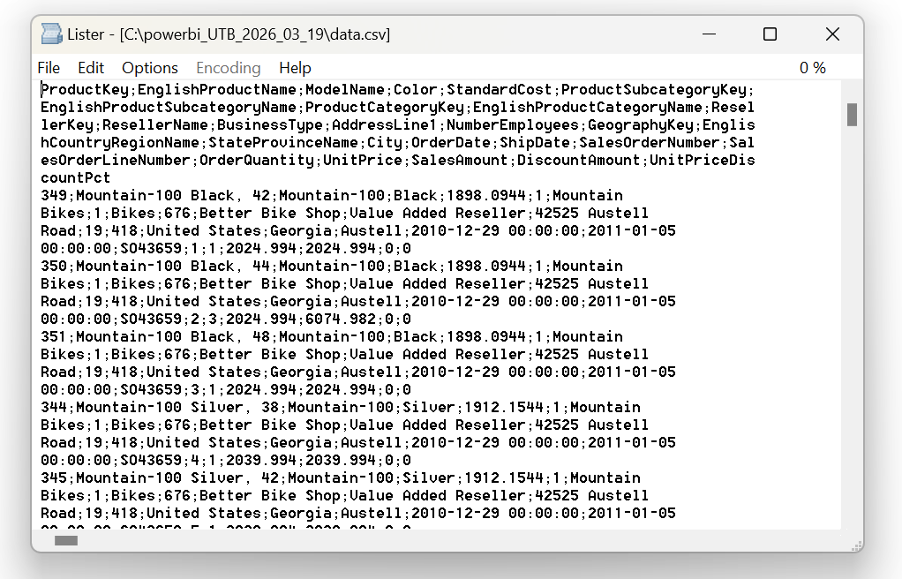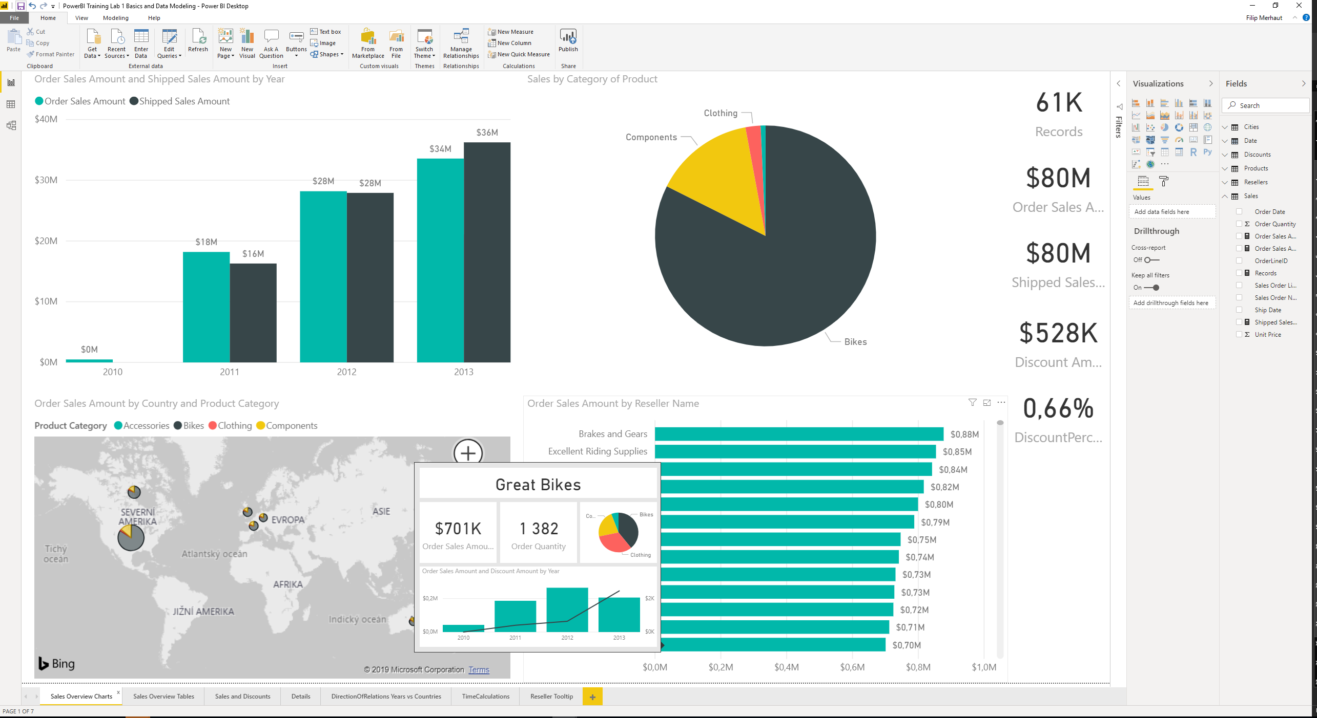
Business case description
A fictional company called Adventureworks is producing bikes and also components and accessories for them. We have their sales data for 2010-2013 in terms of money income, sold quantities and provided discounts. We can analyze this data from typical business intelligence perspectives – what (product was sold), where (it was sold), when (it was sold), by whom (it was sold).
Learning case description
Input data is provided as single file (CSV). Everything needed (products, resellers, locations, sales, discounts) is mixed together into a single file. First step of this lesson to teach you how to obtain and transform the data into separate “business” tables. Then we will build a data model from these tables and add DAX Measures (they are provided in separate file DAX_measures.txt) to them. Finally, we will create visualizations (time perspective, product perspective, geography perspective, resellers perspective), including little more advanced features like drilldowns, drill-through to detail, tooltip. Slightly advanced topic is the time analysis page – e.g. we want to compare in each line the sales for current period (year, month, week, ..) with sales for the same period last year (same month last year, same week last year, ..). Challenge in the data modeling is the fact that each order has two different dates – date when the order was placed and date when the order was shipped. We can link Calendar table to only one of those dates (ordered/shipped), so we need to add inactive relation in order to be able to display Ordered Sales Amount and Shipped Sales Amount at the same time next to each other in one chart/table.
List of high-level steps:
- Get data using Power Query - read from CSV file data.txt (in zip file data.zip in github)
- Transform data using Power Query – create individual tables Products, Resellers, Locations, Sales, Discounts. In general, select columns, remove duplicates convert data, merge columns, rename columns.
- Create Data model in “Model View”: create hierarchies, create “Calendar” table (DAX function CALENDARAUTO() + add columns like Year, Month, Month Sort), check auto-created/create realtions between tables
- Create DAX Measures in tables Resellers, Sales, Discounts. Copy & Paste the DAX formulas from file DAX_measures.txt
- Create Visualizations in Report View: Sales Overview Charts, Sales Overview Tables, Details, Time Intelligence, Tooltip
- (Optional) Publish report to the Power BI service https://app.powerbi.com
Expected results
Power Query
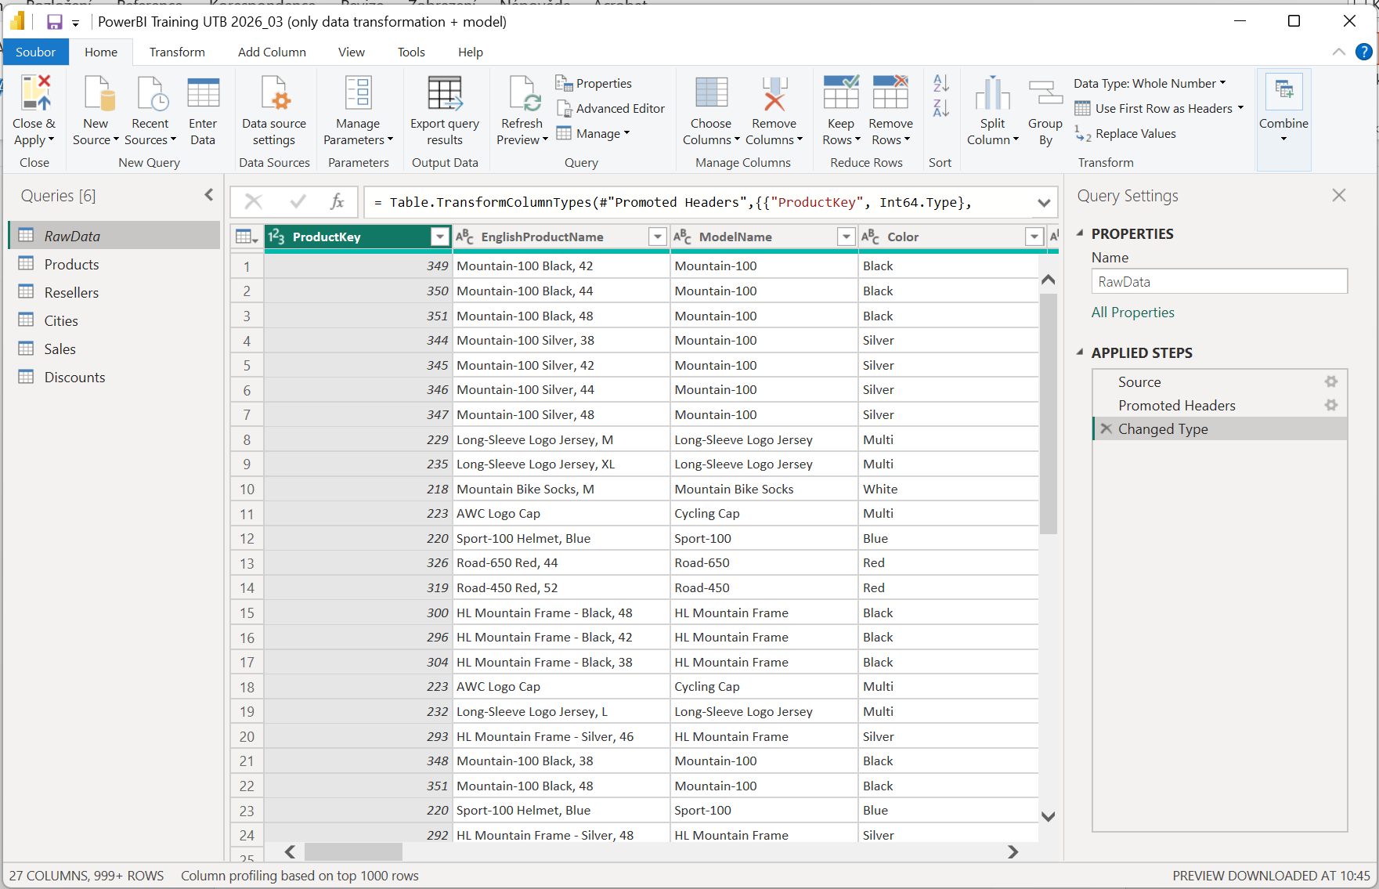
Data Model
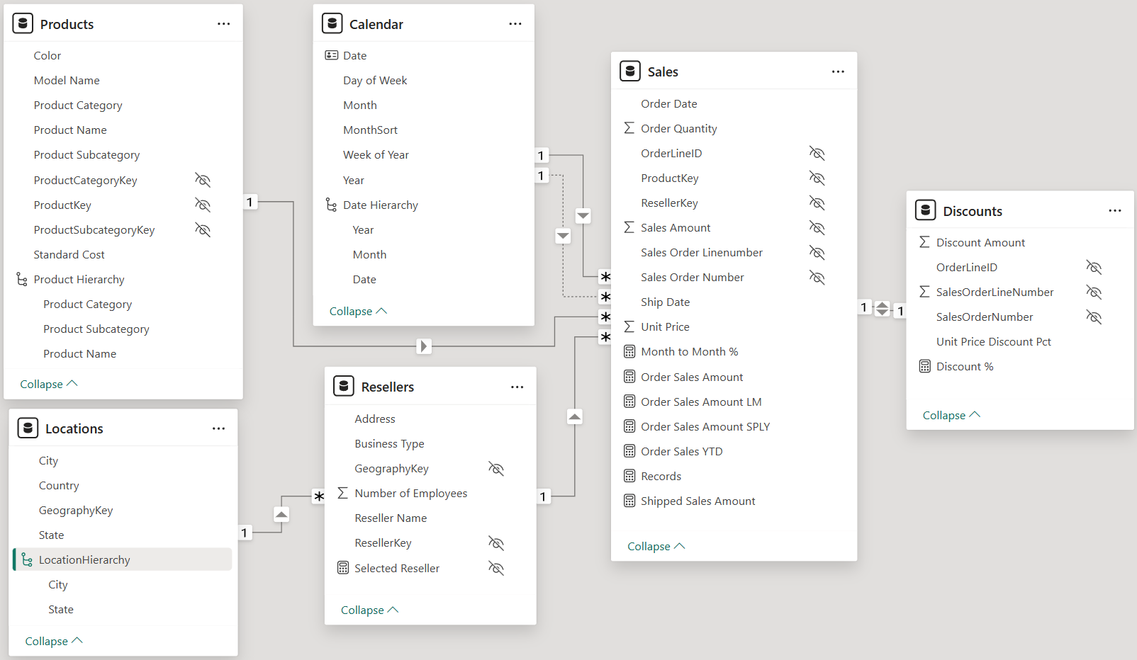

Visualizations
Page “Sales Overview Charts”
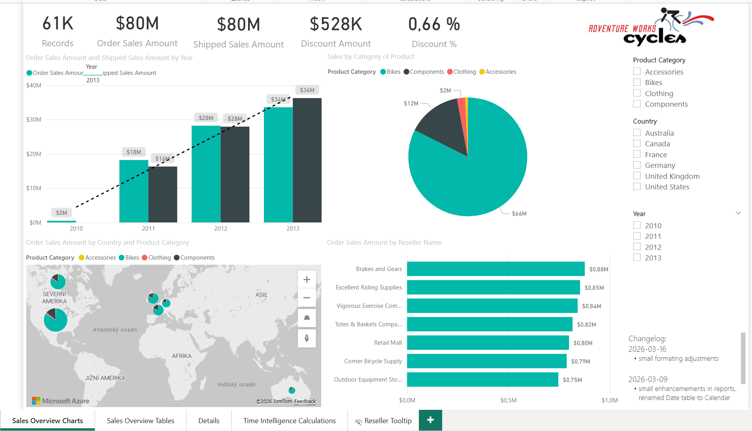

Page “Sales Overview Tables”
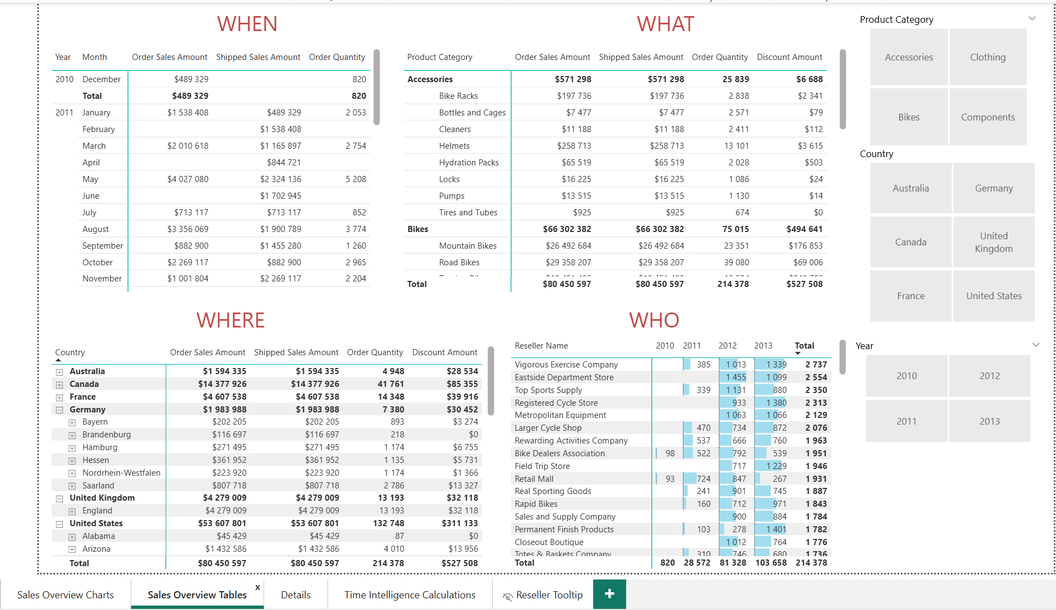

Page “Details”
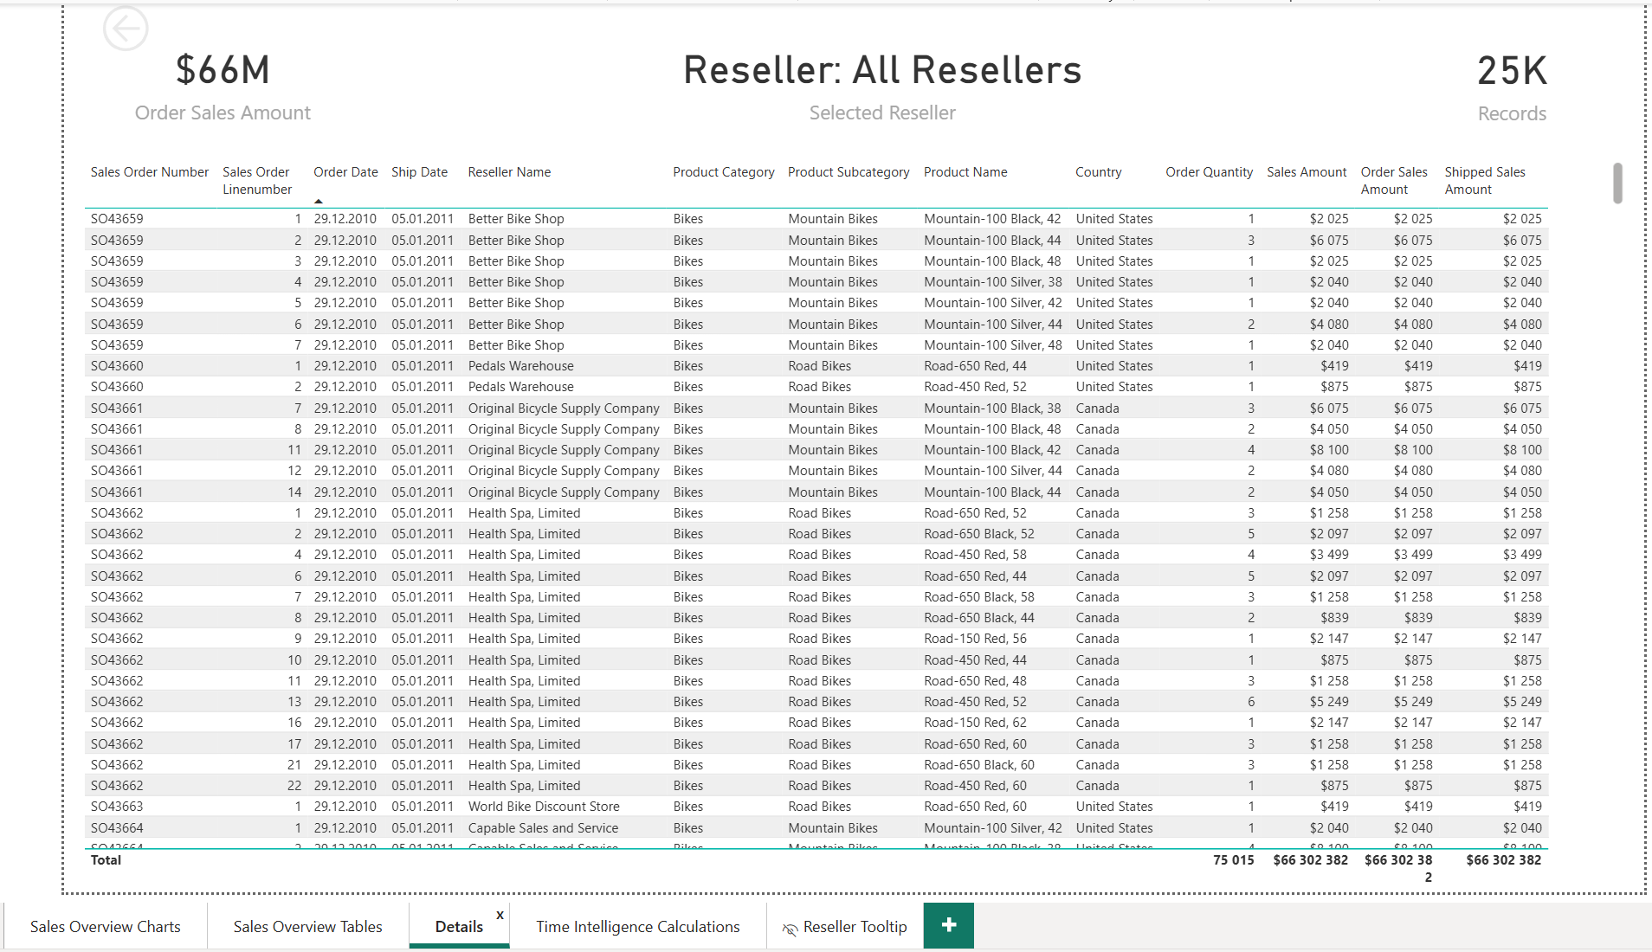

Page “Time Intelligence Calculations”
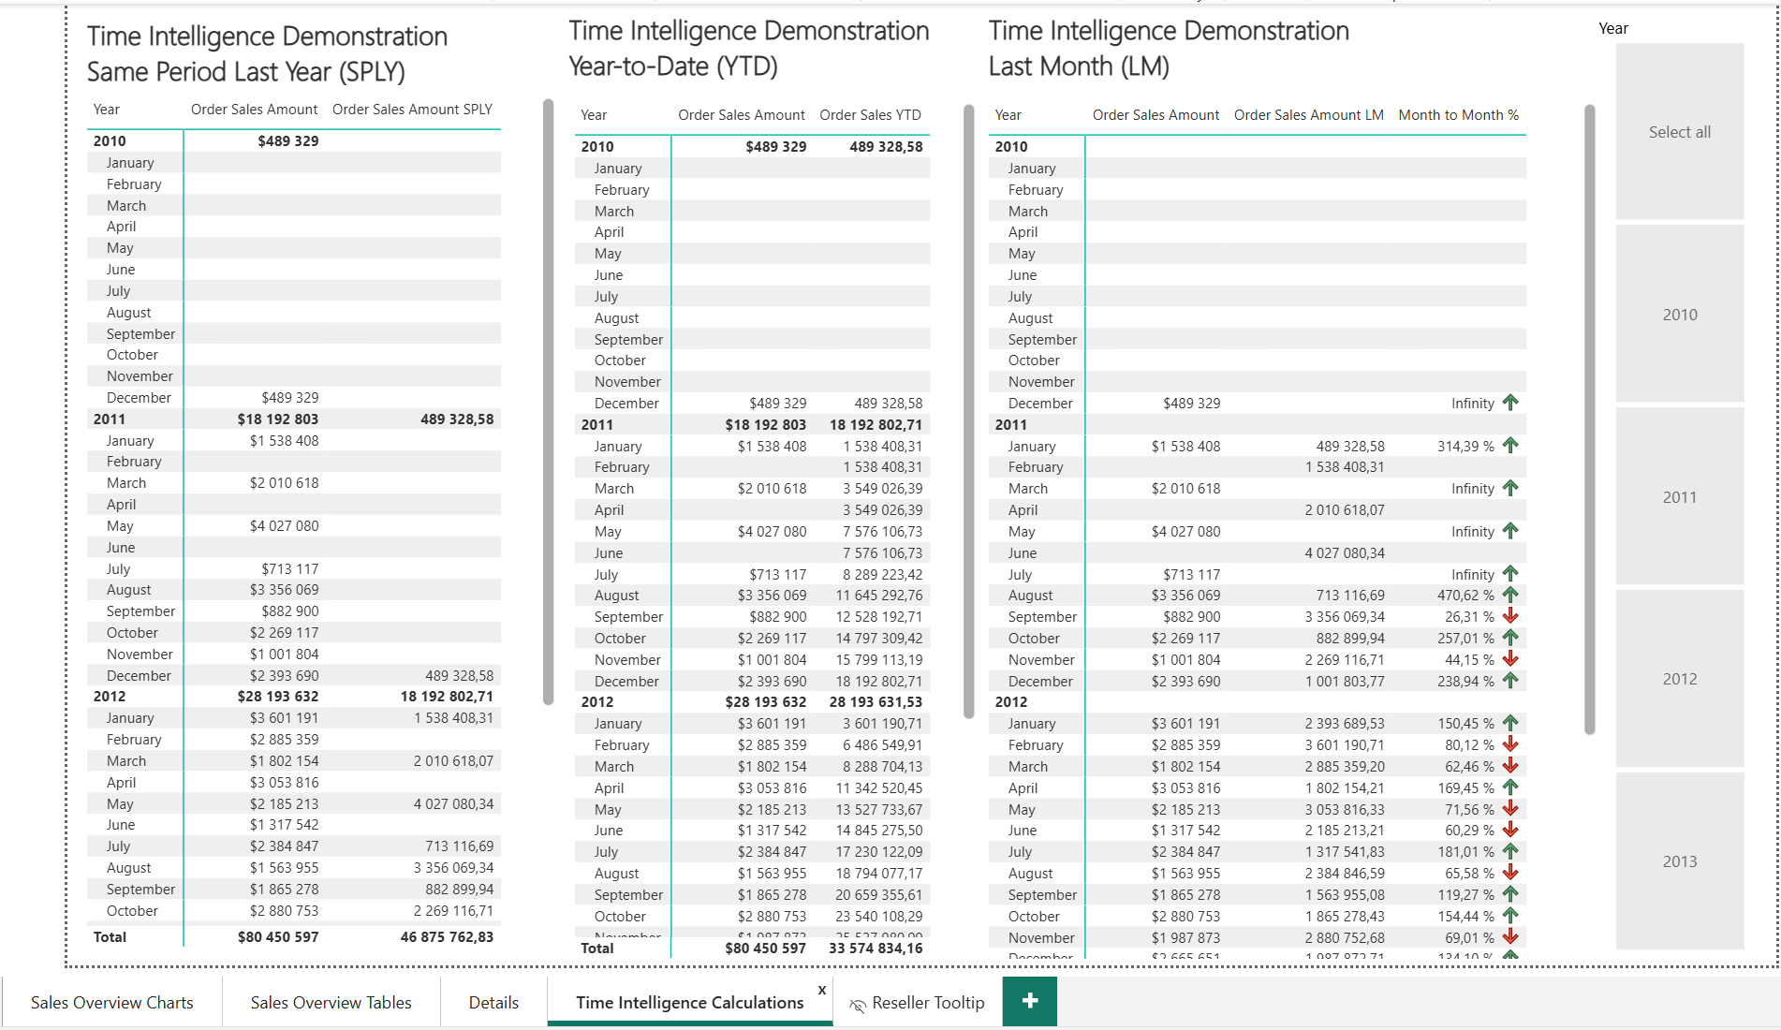

Page “Reseller Tooltip”
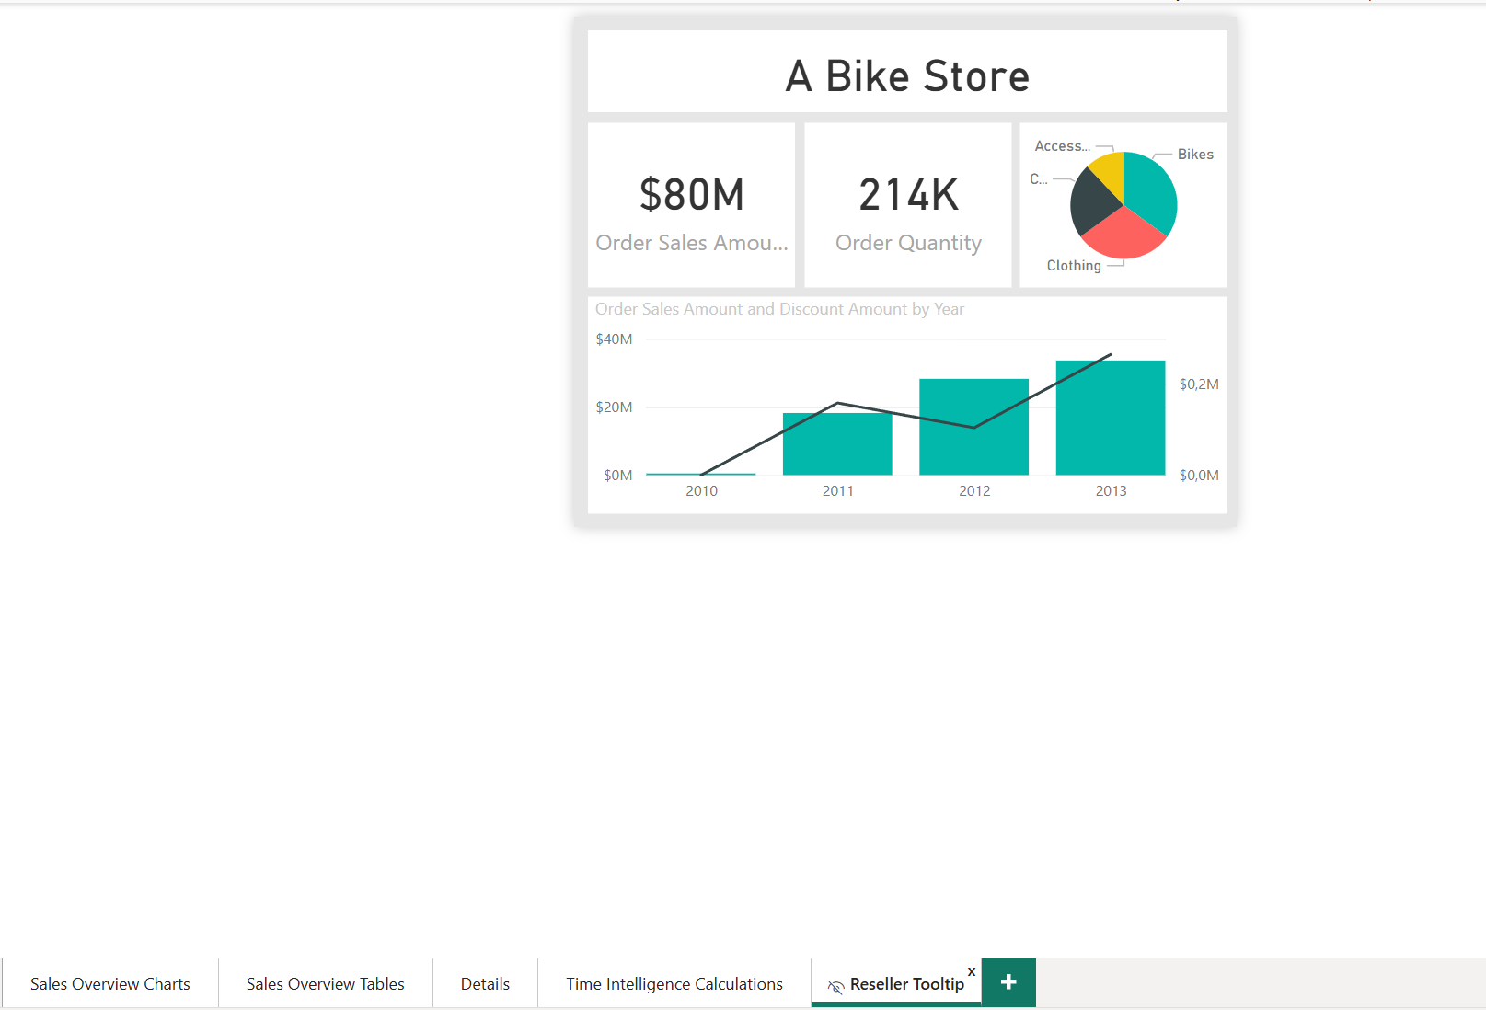

Bonus tasks
- Analyze the sales of products based on their colors: is there any color that sales the most or is the distrubition of sales based on this criterie more or less even?
- Add the chart (new page) with 10 months of forecast for the Order Sales Amount
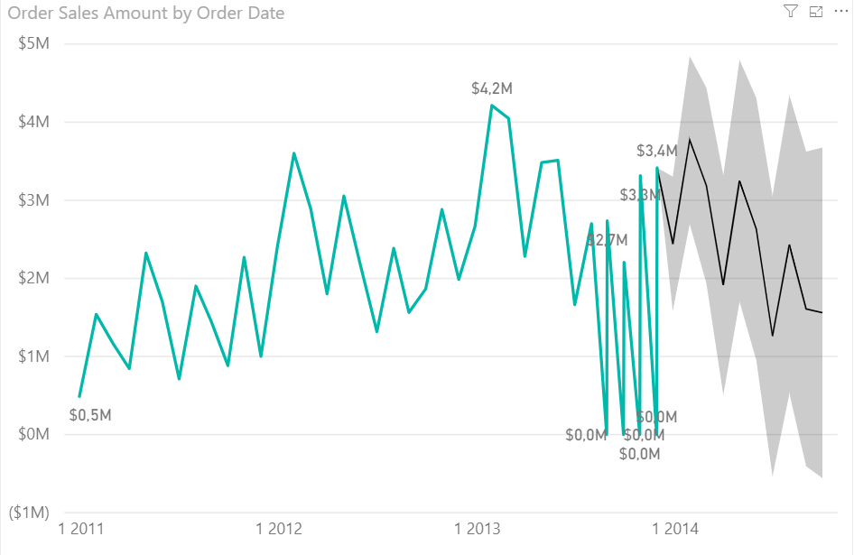
- Rewrite the source data.csv file on disk with new larger file “AdventureWorks_Sales_2010_2016_v1.csv” (available in github in zip “AdventureWorks_Sales_2010_2016_v1.zip”) and refresh the report to simulate live data
- Publish report to the Power BI Service https://app.powerbi.com (create free account using your school or work email address)
- Create Mobile version of your report, publish the new version to the service and open the report in IOS/Android mobile/table Power BI application (you have to install on your phone/tablet from respective App Store; its free)

